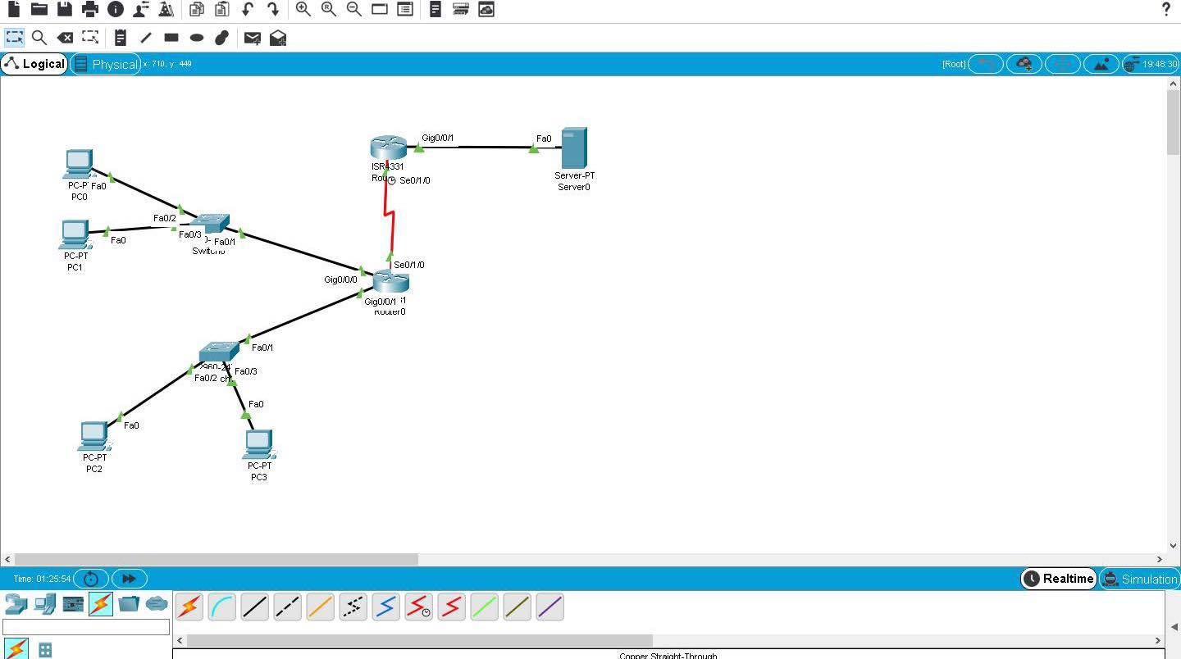

Tue Apr 11 18:35:11 2023 Router0 Router>en

Tue Apr 11 18:35:15 2023 Router0 Router#conf t

Tue Apr 11 18:35:24 2023 Router0 Router(config)#int gig0/0/0

Tue Apr 11 18:35:36 2023 Router0 Router(config-if)#ip add 10.10.10.254 255.255.255.0

Tue Apr 11 18:35:48 2023 Router0 Router(config-if)#exit

Tue Apr 11 18:35:54 2023 Router0 Router(config)#int gig0/0/1

Tue Apr 11 18:36:26 2023 Router0 Router(config-if)#ip add 10.10.20.254 255.255.255.0

Tue Apr 11 18:36:50 2023 Router0 Router(config-if)#exit

Tue Apr 11 18:36:50 2023 Router0 Router(config)#interface GigabitEthernet0/0/0

Tue Apr 11 18:36:54 2023 Router0 Router(config-if)#exit

Tue Apr 11 18:36:54 2023 Router0 Router(config)#interface GigabitEthernet0/0/1

Tue Apr 11 18:37:01 2023 Router0 Router(config-if)#no shutdown

Tue Apr 11 18:37:03 2023 Router0 Router(config-if)#exit

Tue Apr 11 18:37:03 2023 Router0 Router(config)#interface GigabitEthernet0/0/0

Tue Apr 11 18:37:05 2023 Router0 Router(config-if)#no shutdown

Tue Apr 11 18:39:57 2023 Router2 Router>en

Tue Apr 11 18:40:14 2023 Router2 Router#conf t

Tue Apr 11 18:40:42 2023 Router2 Router(config)#int gig0/0/1

Tue Apr 11 18:41:19 2023 Router2 Router(config-if)#ip add 8.8.8.9 255.0.0.0

Tue Apr 11 18:41:27 2023 Router2 Router(config-if)#no shut

Tue Apr 11 18:43:02 2023 Router0 Router(config-if)#exit

Tue Apr 11 18:43:14 2023 Router0 Router(config)#router eigrp 10

Tue Apr 11 18:44:08 2023 Router0 Router(config-router)#network 10.10.10.0 0.0.0.255

Tue Apr 11 18:45:18 2023 Router0 Router(config-router)#network 10.10.20.0 0.0.0.255

Tue Apr 11 18:45:30 2023 Router0 Router(config-router)#no auto-summary

Tue Apr 11 18:45:52 2023 Router2 Router(config-if)#exit

Tue Apr 11 18:46:03 2023 Router2 Router(config)#router eigrp 10

Tue Apr 11 18:47:03 2023 Router2 Router(config-router)#network 8.8.8.9 255.255.255.0

Tue Apr 11 18:47:10 2023 Router2 Router(config-router)#no auto-summary

Tue Apr 11 18:57:03 2023 Router0 Router>en

Tue Apr 11 18:57:06 2023 Router0 Router#conf t

Tue Apr 11 18:57:47 2023 Router0 Router(config)#int se0/1/0

Tue Apr 11 18:58:17 2023 Router0 Router(config-if)#ip add 1.1.1.1 255.255.255.252

Tue Apr 11 18:58:28 2023 Router0 Router(config-if)#no shut

Tue Apr 11 18:58:47 2023 Router0 Router(config-if)#exit

Tue Apr 11 18:58:47 2023 Router0 Router(config)#interface Serial0/1/0

Tue Apr 11 18:59:10 2023 Router2 Router>en

Tue Apr 11 18:59:13 2023 Router2 Router#conf t

Tue Apr 11 18:59:26 2023 Router2 Router(config)#int se0/1/0

Tue Apr 11 19:00:03 2023 Router2 Router(config-if)#ip add 1.1.1.2 255.255.255.252

Tue Apr 11 19:00:08 2023 Router2 Router(config-if)#no shut

Tue Apr 11 19:00:30 2023 Router2 Router(config-if)#exit

Tue Apr 11 19:00:40 2023 Router2 Router(config)#router eigrp 10

Tue Apr 11 19:05:04 2023 Router0 Router(config-if)#exit

Tue Apr 11 19:05:04 2023 Router0 Router(config)#interface GigabitEthernet0/0/0

Tue Apr 11 19:05:27 2023 Router0 Router(config-if)#exit

Tue Apr 11 19:05:27 2023 Router0 Router(config)#interface GigabitEthernet0/0/1

Tue Apr 11 19:05:53 2023 Router0 Router(config-if)#exit

Tue Apr 11 19:05:53 2023 Router0 Router(config)#interface Serial0/1/0

Tue Apr 11 19:06:32 2023 Router2 Router(config-router)#network

Tue Apr 11 19:06:32 2023 Router2 Router(config-router)#end

Tue Apr 11 19:06:32 2023 Router2 Router#configure terminal

Tue Apr 11 19:06:32 2023 Router2 Router(config)#interface Serial0/1/0

Tue Apr 11 19:06:43 2023 Router2 Router(config-if)#exit

Tue Apr 11 19:06:43 2023 Router2 Router(config)#interface GigabitEthernet0/0/0

Tue Apr 11 19:06:52 2023 Router2 Router(config-if)#exit

Tue Apr 11 19:06:52 2023 Router2 Router(config)#interface GigabitEthernet0/0/1

Tue Apr 11 19:11:35 2023 Router0 Router(config-if)#exit

Tue Apr 11 19:11:44 2023 Router0 Router(config)#router eigrp 10

Tue Apr 11 19:12:01 2023 Router0 Router(config-router)#network 1.1.1.0 0.0.0.3

Tue Apr 11 19:12:17 2023 Router2 Router(config-if)#exit

Tue Apr 11 19:12:27 2023 Router2 Router(config)#router eigrp 10

Tue Apr 11 19:12:40 2023 Router2 Router(config-router)#network 1.1.1.0 0.0.0.3

Tue Apr 11 19:13:24 2023 Router2 Router(config-router)#exit

Tue Apr 11 19:14:46 2023 Router2 Router(config)#ip access-list standard 1

Tue Apr 11 19:15:28 2023 Router2 Router(config-std-nacl)#deny 10.0.0.0 0.255.255.255

Tue Apr 11 19:15:51 2023 Router2 Router(config-std-nacl)#deny 172.19.0.0 0.18.255.255

Tue Apr 11 19:16:18 2023 Router2 Router(config-std-nacl)#deny 192.198.0.0 0.0.255.255

Tue Apr 11 19:16:35 2023 Router2 Router(config-std-nacl)#permit any

Tue Apr 11 19:16:48 2023 Router2 Router(config-std-nacl)#int seo/10/

Tue Apr 11 19:17:18 2023 Router2 Router(config-std-nacl)#int se0/10/

Tue Apr 11 19:18:55 2023 Router2 Router(config-std-nacl)#exit

Tue Apr 11 19:19:17 2023 Router2 Router(config)#int seo/10/

Tue Apr 11 19:19:26 2023 Router2 Router(config)#int se0/10/

Tue Apr 11 19:20:26 2023 Router2 Router(config)#int se0/1/0

Tue Apr 11 19:20:58 2023 Router2 Router(config-if)#ip access-group 1 in

Tue Apr 11 19:25:45 2023 Router0 Router>en

Tue Apr 11 19:25:49 2023 Router0 Router#conf t

Tue Apr 11 19:27:07 2023 Router0 Router(config)#ip access-list standard 2

Tue Apr 11 19:28:41 2023 Router0 Router(config-std-nacl)#permit 10.0.0.0 0.255.255.255

Tue Apr 11 19:28:50 2023 Router0 Router(config-std-nacl)#exit

Tue Apr 11 19:29:36 2023 Router0 Router(config)#ip nat inside source list 2 interface se0/1/0 overload

Tue Apr 11 19:30:00 2023 Router0 Router(config)#int se0/1/0

Tue Apr 11 19:30:41 2023 Router0 Router(config-if)#ip nat outside

Tue Apr 11 19:30:56 2023 Router0 Router(config-if)#int gig 0/0/0

Tue Apr 11 19:31:05 2023 Router0 Router(config-if)#ip nat inside

Tue Apr 11 19:31:23 2023 Router0 Router(config-if)#int gig0/0/1

Tue Apr 11 19:31:34 2023 Router0 Router(config-if)#ip nat inside

Tue Apr 11 19:34:54 2023 Router0 Router(config-if)#exit

Tue Apr 11 19:35:01 2023 Router0 Router(config)#do show run